New Jersey Dance to Inspire

2019-2020 Class Schedule
Ages 9-11
Jazz: Mon. @ 5 pm
Hip Hop: Fri. @ 5:30 pm
Ballet: any 9+ class
Monday | Tuesday | Wednesday | Thursday | Friday | Saturday
5:00 pm  JTB  Ages 4-5 | 4:00 pm  Little Dreamers  18 months-3 | 4:30 pm  Jazz  Ages 6-8 | 4:30 pm  Hip Hop  Ages 12+ | 4:30 pm Ballet  Ages 6-8 | 9:00 am  Mommy & Me  Ages 2-3
**6:00 pm  Jazz  Beginner  Invitational | **5:00 pm  Contemporary  Invitational | 5:30 pm  Ballet/Floor  Ages 9+ | **5:30 pm  Hip Hop  Invitational | 5:30 pm  Hip Hop  Ages 9-11 | 10:00 am  Technique/Acro  Ages 9+
**7:00 pm  QUEEN  TAKEOVER  Invitational | **6:00 pm  Musical Theater  Invitational | 6:30 pm  Jazz  Ages 12+ | 6:30 pm  Technique/Leaps & Turns – Flexibility  Ages 9+ |  | 11:00 am  Hip Hop  Ages 6-8
8:00 pm  Improv  Ages 12+ | **7:00 pm  Ballet/Pointe  Invitational | **7:30 pm  Jazz  Invitational | **7:30 pm  Lyrical  Invitational
**7:45 pm
Ballet
Invitational

Ballet/Technique
Pay for ONE, try ALL CLASSES! (May only take one class per week, however; class can vary each week.)
*Non-competition students only.*
Wednesday – 5:30 pm Ballet/Floor
Thursday – 6:30 pm Technique/Leaps & Turns
Saturday – 10 am Technique/Acro

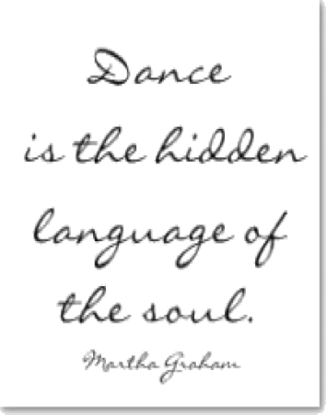

Ages 12+
Improv: Mon. @ 8 pm
Hip Hop: Thurs. @ 4:30 pm
Jazz: Wed. @ 6:30 pm
Ballet: any 9+ class

Ages 2-3
Mommy & Me
Saturday @ 9:00 am
Tuesday @ 4pm
Ages 6-8
Jazz: Wed. @ 4:30 pm
Ballet: Fri. @ 4:30 pm
Hip Hop: Sat. @11 am
Ages 4-5
Monday Ja Jazz/Tap/Ballet
Tuesday @ 4 pm
Jazz/Tap/Ballet 5pm

